EXPERIMENT – 2
NAME – SUMANSHU JINDAL | UID – 24BCS11091
BRANCH – BE – CSE | SECTION/GROUP – 24BCS_APP-707A
SEMESTER – 5th | DATE OF PERFORMANCE – 8/9/2026
SUBJECT NAME – COMPETITIVE CODING | SUBJECT CODE – 24CSP – 305

Aim – To efficiently find all unique quadruplets in an array summing to a given target value.
Objectives
- Apply sorting and two-pointer techniques to array-based search problems.
- Eliminate duplicate quadruplets efficiently using sorted order and skipping.
- Analyze time and space complexity of the implemented algorithm.
- Test solutions using normal, boundary, and edge case inputs.
Theory
The array is sorted in ascending order first. Two nested loops fix the first two elements while skipping repeated values. A two-pointer scan then finds the remaining pair whose sum equals the target. Duplicates are skipped, and pruning stops unnecessary iterations early. Time complexity is O(n³); auxiliary space is O(1).
IMPLEMENTATION/INPUT CODE
#include <iostream>
#include <vector>
#include <algorithm>
using namespace std;

vector<vector<int>> fourSum(vector<int>& nums, int target) {
vector<vector<int>> result;
int n = nums.size();
if (n < 4) return result;
sort(nums.begin(), nums.end());

for (int i = 0; i < n - 3; ++i) {
if (i > 0 && nums[i] == nums[i - 1]) continue;
if ((long long)nums[i] + nums[i + 1] + nums[i + 2] + nums[i + 3] > target) break;
if ((long long)nums[i] + nums[n - 3] + nums[n - 2] + nums[n - 1] < target) continue;

for (int j = i + 1; j < n - 2; ++j) {
if (j > i + 1 && nums[j] == nums[j - 1]) continue;
if ((long long)nums[i] + nums[j] + nums[j + 1] + nums[j + 2] > target) break;
if ((long long)nums[i] + nums[j] + nums[n - 2] + nums[n - 1] < target) continue;

int left = j + 1, right = n - 1;
while (left < right) {
long long sum = (long long)nums[i] + nums[j] + nums[left] + nums[right];
if (sum == target) {
result.push_back({nums[i], nums[j], nums[left], nums[right]});
++left; --right;
while (left < right && nums[left] == nums[left - 1]) ++left;
while (left < right && nums[right] == nums[right + 1]) --right;
}
else if (sum < target) ++left;
else --right;
}
}
}
return result;
}

int main() {
int n, target;
cin >> n;

vector<int> nums(n);
for (int &x : nums)
cin >> x;
cin >> target;

vector<vector<int>> result = fourSum(nums, target);

for (auto &quad : result) {
for (int x : quad)
cout << x << " ";
cout << "\n";
}
return 0;
}
OUTPUT
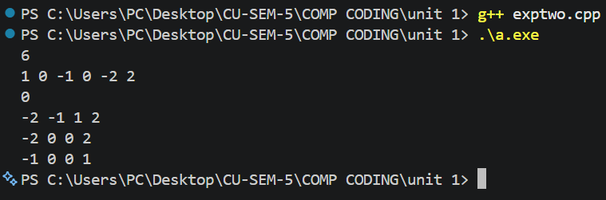
Learning Outcomes
- Understand how sorting enables efficient two-pointer searching within large arrays.
- Avoid duplicate results by skipping repeated elements at every level.
- Prevent integer overflow by using long long for sum calculations.
- Reduce iterations using pruning based on minimum and maximum sums.
- Analyze time complexity O(n³) and auxiliary space complexity O(1) accurately.

